Revision Grade 12

Teachers have cover the following topics for you to complete this revision:
    - Personal Mission Statement- Grade 11
    - Stress – stressors, managing stress and change to promote quality of life Grade 12
    - Applications for jobs/ study as well as the Curriculum Vitae. Grade 11
    - Counteracting unemployment Grade 12
    - Entrepreneurship Grade 12

Complete each of the following options that you can pursue after Grade 12:
OPTION 1 GET A JOB!

OPTION 2 STUDY AFTER SCHOOL!

OPTION 3 SELF-EMPLOYMENT!

Activity 1: Research Assignment

Option 1: Purpose
The purpose of option 1 is to prepare Grade 12 learners with adequate information for the world of work and to ensure learners have an understanding of the realities of the South African job market,
GET A JOB!

    - Identify three jobs in order of preference and give two reasons why you
intend pursuing each job? (9)
1.1.2 State the title of the job that you have identified as your first preference and briefly give a description of that job. (4)
    - You are required to cut out and paste (or write out if taken from the internet or you can also print) two job advertisements on your preferred field. You must show some evidence (dates, web address and actual advert) and note well
that all information must be current and relevant to your field. (4)
    - Write a critical explanation on each of the following:
Add to your information by researching information from books,
magazines, people who are in the profession or field, journal articles, career
books or speaking to career counselors.
- The availability of jobs in your preferred field. (4)
- The reasons for unemployment in South Africa and globally. (6)
- Four innovative strategies to counteract possible unemployment. (8)

STUDY AFTER SCHOOL!

Option 2: Purpose

To prepare learners who are entering higher education institution to access bursary/ scholarships/ bank loans / University grants / private aid / grants
To assist learners in filling in application forms and create awareness of the cut off dates of application forms
To know admission requirements at higher education institutions
To ensure that they have had some support and preparation before entering higher institutions
To be given guidance and counseling in making the best possible choice at a higher education institution.

1.2.1 Identify three courses or study fields / career paths in order of preference and
provide two reasons for each choice. (9)
1.2.2 State the course you have identified as your first preference and briefly
give a description of the course. (4)
    - State the minimum admission requirements for you chosen course. Ensure that
your information is current and relevant. (2)
1.2.4 Provide two possible financial sources for assistance that you can access for
funding your studies. (2)
1.2.5 Write a critical explanation on each of the following:
Add to your information by researching information from books,
magazines, people who are in the profession or field, journal articles, career
books or speaking to career counselors.
- The high drop out rate (why learners stop their studies) and failure rate in
their first year at colleges or universities. (6)
- What can learners do to overcome this problem (6)
- The availability of jobs in your field after you have completed
your studies. (6)

SELF-EMPLOYMENT!

(Suggestion: recommended to students who are doing business studies)

Option 3: Purpose
To prepare learners for entrepreneurial opportunities / skills. An entrepreneur is simply a person who takes the risk of starting a new business. In South Africa there are many people who will not find jobs. Starting a business is an alternative way of making a living. Starting your own business takes a lot of passion and commitment. You will need to have an excellent understanding of yourself and of the market in which you want to start your business. Not only that, but you will also need to know people who will help you guide you in reaching success. Can you start your own business?

1.3.1 Design a business plan for your venture using the following headings:

a) Give one business opportunity that you would like to pursue. (1)

b) Explain the findings from you’re the research that you have done to identify the niche market for your business? (6)
(To gather information you can talk to people who have been in the business, research information from books or the internet, survey the market or any other)

c) Conduct a SWOT analysis on your business and write a short essay of 10 to 15 lines on the strengths, weaknesses, opportunities and challenges that your business may present. (10)
d) Explain the role/s and responsibilities that your business will require. (4)
e) Explain the venue/ location from which you are going to operate and what equipment you will need. (4)
f) State your intended marketing strategy. (5)

1.3.2 Explain your back up plan if your first business venture is not successful. (5)

Business Plan

Please note the illustrations below are given to assist you in brainstorming ideas for your business plan.
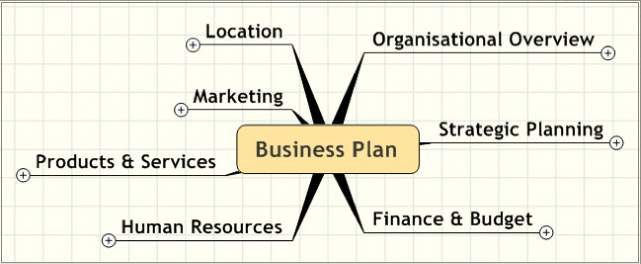
Description
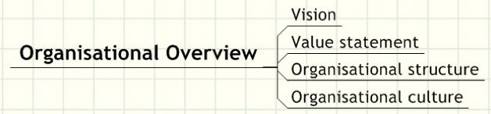

1. What do you do?
2. What do you want to achieve?
Planning
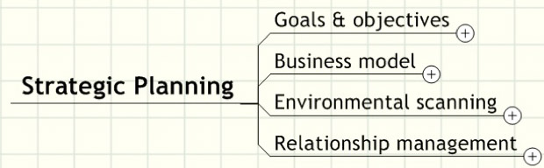

3. What are your goals and objectives?
4. What are your short-term goals? (within a year).
5. What are your long-term goals? (within 5 years).
6. What is your operational plan? (plan to achieve goals).
7. Who are your potential competitors?

_ ________________________________________________________________
Finance and Budget
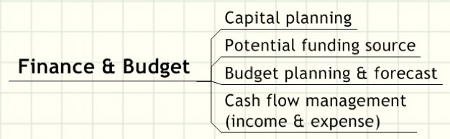

8. How much money will you need?
9. Where can you get funding from?
10. What will your monthly budget be?
11. How will you control your income and expenses?
_________________________________________________________________
Human Resources
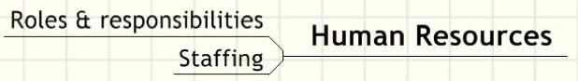

12. “Who” is responsible for “What”?
13. “Who” (in terms of expertise and personal character) do you need?
_________________________________________________________________
End Product / Services offered
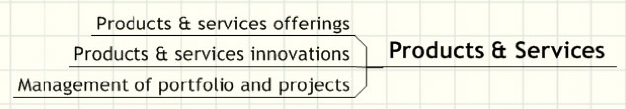

14. What are your main products or services?
15. How do you deliver main products or services?
16. How do you come up with new products or services?
________________________________________________________________
Marketing

17. Who is your customer?
18. How do you market your products and services to your target market and
target customer?

________________________________________________________
Location of my business
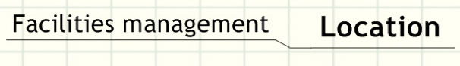

19. Where do you operate from?
20. What facilities or equipment will you need?

ACTIVITY 2: INVESTIGATION

The following topics/ themes are to be covered before the learners attempt this activity:
- Types of stress
- Stressors
- Managing stress / coping mechanisms
- Relevant terminology

This activity integrates the world of work and stress situations or stress factors one may experience at the work place. It challenges learners to confront the stressors (positive or negative) that they may experience in their chosen career, to evaluate and provide solutions to manage such stress.

Instruction

Investigate stress within your chosen career field or the workplace in general to answer the questions below. You may interview a person in your chosen job / career field, consult career guides, refer to websites, career pamphlets, and use the library or any other reliable source.

2.1 Give by means of examples five (5) stress related situations / stressors
one may encounter in your chosen job / career field or the workplace in
general. (5)

2.2 List and discuss 5 strategies or skills one can apply to manage stress supported by relevant sources. (In other words, substantiate all the statements that you make). (10)

ACTIVITY 3: CASE STUDY

The following topics/ themes are to be covered before this activity:

- Basic Conditions of Employment Act
- Labour Relations Act
- Discrimination in the work place
- Work Ethics
- Importance of building and sustaining positive relationships in the work place

Read the CASE STUDY below and answer the questions that follow:

Thembi was a fresh graduate when she joined Mdlulile and Mantu Associates as an administration clerk.

Being new in the company and eager to learn, she found herself working almost 50 hours per week and even working on holidays without extra remuneration. Some days, especially towards the end of the month, she would work during her lunch break in order not to lag behind with her work. Worst of all, she even came to work when she was ill.

Frequently, Mr. Mdlulile – a married man and father of two - would ask her to remain behind after work so that she could type his personal notes. During that time he would make suggestive statements which made Thembi cringe. Each time he saw Thembi he would want to kiss her or stroke her back. Because of her refusal to continue staying after work, Mr. Mdlulile has given Thembi a poor performance appraisal. He does not greet her anymore and constantly complains about her work, regardless of her efforts. Recently, Thembi lost her mother due to illness, and the company refused to give her some days off to help with the funeral arrangements.

When Thembi reported that she might be pregnant, he recommended that she be dismissed as the company could not accommodate unwed mothers.

  - Basic Conditions of Employment Act (BCEA)

3.1.1 Identify 5 practices in the above case study that are in contravention of the
Basic conditions of employment Act (5)
    - What, according to the Basic conditions of employment Act applies with regard
to the contraventions that you’ve identified? (5)

  - Ethics in the work place:
    - What unethical behaviour is taking place in the case study? Name two. (2)
    - What can Thembi do to deal with the unethical behaviour. Name 4 actions she
can take. (4)
  - Discrimination:
    - What is meant by discrimination? (2)
    - Identify the form of discrimination in the case study. (1)
    - How should discrimination in the work place be dealt with? (4)
    - Which two (2) labour laws protect the employee against discrimination in the
work place? (2)
Activity 4

Carefully study the comic strip below and answer the questions which follow:
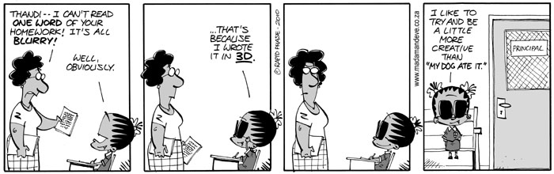
The way in which one approaches one’s studies often plays an important part in how successful one is.

4.1. Say why it is important to be conscientious when doing homework. (1)

4.2. State why it is important to be self-motivated when working for one’s exams. (2)

4.3. Name THREE things that one must plan for when drawing up a study plan. (3)

4.4. Suggest why it is important to include time for physical activities in a
study plan. (2)

4.5. Justify how a well-structured study plan can be invaluable to exam success (2)

Activity 5
Read the following letter and answer the questions that follow:

Dear Madam,

I am very concerned about what is going on in many countries. It seems that the freedom of the press is slowly disappearing. My son is a journalist and he travels a lot to other countries. He is often harassed by the police and government officials in some of those countries.

It seems, that instead of good, honest, open and democratic debate, we have officials prepared to tell journalists what they must write and newspapers what they must publish. If this is what is going to happen, then problems will never be solved.

Think of all these problems: poor education, bad health services, lack of housing, homeless people, unemployment – and these are just some. Surely the media have to get people to start talking about these issues and hopefully get some action from authorities.

Any democratic government would welcome the participation of its citizens in helping create good policies. But these governments that harass my son only want to feather their own nests. They don’t want interference from the press. My son is just trying to be a good, investigative journalist; he wants transparency and accountability.

If the media does not inform people about what is really going on, how can the people ever have a better life?

Sincerely
Roxanna B

5.1 What is your understanding of media freedom / freedom of the press?
Define this term. (2)

5.2 Why do you think media freedom is in the national interest of South Arfica? (4)

5.3 Do you think the media in South Africa promotes democracy?
Justify your answer by giving reasons for your answer and examples of when this
has/has not happened. (4)

Activity 6

Read the article below and answer all the questions that follow
Ficksburg service delivery death raises questions about police brutality
At least three buildings were burned down and streets were blockaded. The day before, Andries Tatane was beaten and shot dead, allegedly by a group of policemen. The vicious assault by at least six policemen shocked the nation when it was shown on prime-time TV news bulletins.
Last night, police and thousands of residents of Meqheleng, Tatane’s home township, and of neighboring townships, were still locked in a tense stand-off. Entry to the area was restricted as violence flared. Residents threw a variety of missiles at the police, including petrol bombs.
What was meant to be a peaceful demonstration against service-delivery failure turned violent on Wednesday after police repeatedly struck Tatane with batons, kicked him and allegedly shot him twice.
Footage of the 33-year-old married father of one collapsing in front of the protesters, and dying about 20 minutes later, has been described as damning evidence of police brutality.
It incited anger that yesterday led to hundreds of protesters setting alight the Ficksburg offices of the departments of Home Affairs and of Pblic Works at midday. Several schools closed as pupils – some of whom Tatane tutored in Maths, Science and Afrikaans – joined the protest.
“They killed Andries like a dog and they expect us to listen to them,” said one protester. “Voetsek! Our lives are worth much more than just an apology after their reckless actions. The police are murderers,” he said.
Protest-march organiser and chairman of the Meqheleng Concerned Citizens group, Sam Motseare, said: “The community is very angry as a result of what unfolded yesterday.” Motseare described the attack on Tatane as “police brutality typical of the apartheid system”.
Tatane’s family has demanded answers from the police. The family went to the spot yesterday where he was killed. Tatane’s wife and siblings wept as a priest prayed that his soul would find peace – and for those responsible to be brought to book.
“It has been a very difficult two days,” said Tatane’s brother, Lefu. “It still seems so unreal. We have to start making funeral arrangements, but it hurts too much.” The family home has been inundated with visitors paying their respects
A team from the Independent Complaints Directorate was sent to investigate the killing and has been ordered to finalise the case quickly. Directorate spokesman Moses Dlamini said the postmortem would be conducted today.
“Following the completion of all investigations, we will send our findings to the Director of Public Prosecutions to make a decision. The police will have to decide on what actions to take against any policemen implicated,” said Dlamini.
None of the police officers involved in the attack have been suspended, but they have been transferred to other areas. National Police Commissioner Bheki Cele’s office refused to comment, saying Police Minister Nathi Mthethwa had already spoken about the case. Neither of them has visited Tatane’s family.
Mthethwa urges the public to allow the investigation to take its course. “ From where we are, it will be improper to draw conclusions on the incident but [we] remain confident that an impartial investigation will inform us what transpired, who were in the wrong and so forth,” he said. Mthethwa said he was confident that the Independent Complaints Directorate would investigate the incident without delay and “without fear or favour”.
Teenactive.

6.1 Did the protestors have a right to protest against bad service delivery in their district?
Name the right according to the Bill of Rights. (2)

6.2 What type of issue were they protesting against? (1)

6.3 Which of Tatane’s rights were violated by the police officials? (3)

6.4 Assess the handling of this situation by the South African police force.
How should the S.A police force have handled the situation (4)

Activity 7

Many of the Grade 11 learners at your school pay little attention to their portfolio tasks.
They argue that these are not important as they only count 25% of the final subject mark.
You are required to give a talk to the Grade 11 learners explaining the importance of continuous assessment and the relevance that portfolios have in the workplace.
7.1 Identify and critically justify the five key points of your talk. (10)

7.2 Explain how being disciplined in completing portfolio tasks will assist you in your
post-school destinations. (5)

Activity 8

As an honest South African citizen, it makes one feel angry when looking at the pictures below.
This is because corruption, bribery and fraud has a negative impact on us individually, as well
as on our community and country.

8.1 Discuss the impact of corruption on:
(a) individuals
(b) the country (10)

8.2 Prepare a short talk on how corruption could be combat. (5)

Activity 9
Carefully study the comic strip below and answer the questions which follow:
The way in which one approaches one’s studies often plays an important part in how successful one is.
9.1. Say why it is important to be conscientious when doing homework? (1)
9.2. Sate why it is important to be self- motivated when working for one’s exams. (2)
9.3. Name three things that one must plan for when drawing up a study plan. (3)
9.4. Suggest why it is important to include time for physical activities in a
study plan. (2)
9.5. Justify how a well structured study plan can be invaluable to exam success (2)

Activity 10 more essay pracitce
10.1. Analyse how a positive work ethic can assist one in achieving exam success. In your
analysis discuss the importance of: Personal motivation and organization; good time
management; self-evaluation.

10.2. Critically evaluate the role of trade unions in the work place In your answer consider
how the trade unions can impact on 1) employers and 2) employees.

10.3. Evaluate the role of SETAS in providing learning opportunities and in creating both
employment and entrepreneurship opportunities among school leavers

10.4. Identify the benefits of a job contract for both the employee and the employer

Remember every essay you write will be out of 15 marks

